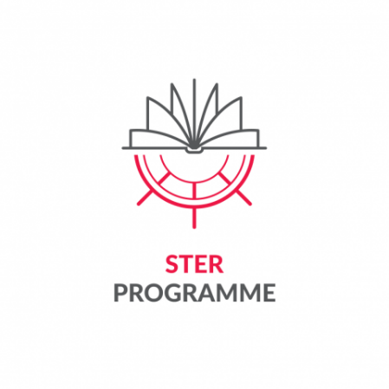


Appendix 6 to the Regulations for Participation in the Task
"Crossing Borders and Horizons" for the best doctoral candidates from Poland and abroad, pursuing education at Interdisciplinary Doctoral School – TUL in the academic year 2026/2027 (2nd edition), as part of the project titled: "IMPROVE International Mission to Promote Research and Optimal Values in Education” implemented by Lodz University of Technology as part of the programme STER - Internationalisation of Doctoral Schools - 2024 Call financed by the National Agency for Academic Exchange
Data Form for the Agreement with the Participant of the Project
Please fill in with capital letters

PARTICIPANT DATA
Name
Surname
PESEL NUMBER
DATE OF BIRTH
ADDRESS OF RESIDENCE  in Poland | Country
ADDRESS OF RESIDENCE  in Poland | Postal Code
ADDRESS OF RESIDENCE  in Poland | City
ADDRESS OF RESIDENCE  in Poland | Street, house number, apartment
Contact telephone number
Email address
E-mail address in the domain @dokt.p.lodz.pl
BANK ACCOUNT DETAILS
(Please provide the same account to which the doctoral scholarship is transferred)
BANK NAME
BANK SWIFT NUMBER
IBAN/BIC
ACCOUNT NUMBER
CURRENCY*
Account holder
* Funds will be transferred in PLN

place and date | signature
…………………………………………………… | …………………………………………………..

