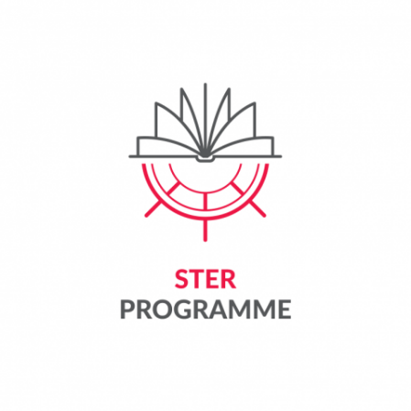


Appendix 5 to the Regulations for participation in the Task
"Crossing Borders and Horizons" for the best doctoral candidates from Poland and abroad,
pursuing education at Interdisciplinary Doctoral School – TUL in the academic year 2026/2027 (2nd edition), as part of the project titled: "IMPROVE - International Mission to Promote Research and Optimal Values in Education” implemented by
Lodz University of Technology as part of the programme STER - Internationalisation of Doctoral Schools - 2024 Call financed by the National Agency for Academic Exchange

Applicant’s assessment sheet for project qualification
Name and surname of the applicant

Formal criteria:
Current Status of a doctoral candidate at IDSTUL | YES o | NO o
Proficiency in a foreign language of at least B2 level (confirmed) | YES o | NO o
I am a citizen of the Russian Federation | YES o | NO o

Substantive criteria:
Criterion | Description | Number of points
- The thematic scope and method of implementation of the planned mobility. | - Assessment of the justification for mobility in the context of needs arising from the doctoral thesis  - Assessment of the expected effects of mobility in the context of the applicant's scientific development  - Assessment of the justification for choosing the host facility  [maximum 30 points]
- The applicant's previous foreign cooperation | - Assessment of the applicant's previous (documented) international cooperation  - Doctoral dissertation prepared in cooperation with a foreign centre; Supervisor/co-supervisor/assistant supervisor from abroad; doctoral dissertation prepared as part of double diplomas  [maximum 40 points]
- Applicant's scientific/artistic achievements to date | - Assessment of the applicant's publication and other achievements (courses, active promotional activities for IDS TUL) relevant to the given discipline  [maximum 30 points]
Total points (max 100)

