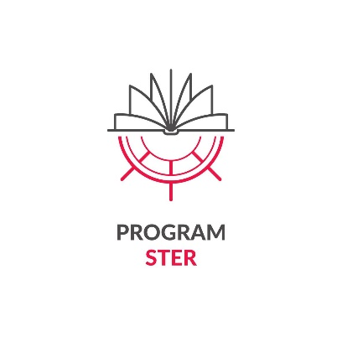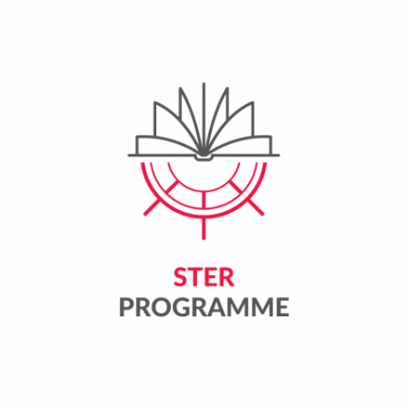****

*Appendix 4*  
 *to the Regulations of participation in the task "International science leaders"*  
 *for the best foreign doctoral candidates and the best doctoral candidates from Poland implementing doctoral projects in international cooperation as part of the international doctoral programme, in particular aimed at obtaining a joint degree or multiple degree - as part of the project entitled: "IMPROVE – International Mission to Promote Research and Optimal Values in Education" implemented by Lodz University of Technology as part of the STER programme - Internationalization of doctoral schools - 2024 call,*  
 *financed by the National Agency for Academic Exchange*

PROJECT PARTICIPANT STATEMENT

|  |  |
| --- | --- |
| Identification data of the programme and project to which the statement relates | |
| Institution announcing the recruitment for the Programme | National Agency for Academic Exchange (NAWA) |
| NAWA Program Name and Year of Announcement | STER NAWA – Internationalization of doctoral schools - 2024 Call |
| NAWA Beneficiary's Name | Lodz University of Technology |
| NAWA Beneficiary's project title | IMPROVE - International Mission to Promote Research and Optimal Values in Education |
| NAWA Beneficiary's project number | BPI/STE/2024/1/00003 |

I, the undersigned

|  |  |
| --- | --- |
| Name |  |
| Surname |  |
| PESEL/passport number |  |
| Function in the NAWA Beneficiary's project | Participant |

I declare that:

1. I accept the rules for the implementation of the NAWA Programme specified in the Announcement on the call for applications for participation in the ‘STER NAWA - Internationalization of Doctoral Schools – Call 2024’ No. 10/2024 of 20.05.2024 and   
     
     
     
   attachments to the above-mentioned Announcements: <https://nawa.gov.pl/instytucje/ster-umiedzynarodowienie-szkol-doktorskich/ogloszenie>;
2. I meet the criteria allowing me to participate in THE NAWA Programme, i.e.

* I am pursuing my training at IDS TUL (i.e. my training at IDS TUL has not been suspended pursuant to Article 204 (3) of the Act and §10 of the Regulations of IDS TUL);
* I have an Individual Research Plan (IRP) submitted and approved by the relevant Discipline Council, in accordance with the IDS TUL Regulations;
* I am following the schedule for preparing my doctoral dissertation, as specified in the IRP, i.e. I have not extended the deadline for submitting my doctoral dissertation;
* I do not receive support from other sources (in the same or similar scope as that available under the project) which would result in double financing of expenses;
* I am preparing my doctoral dissertation in a foreign language – English;
* I implement a doctoral project in international cooperation as part of an international doctoral programme, in particular aimed at obtaining a joint degree or a multiple degree (applies to doctoral candidates from Poland).

I have been informed of the criminal liability under Article 233 of the Criminal Code for making false statements or concealing the truth, which is punishable by up to 3 years of imprisonment. I declare that the information provided in this Statement is complete and true.

I acknowledge that this information may be subject to verification as to its accuracy.

…………………………………………………………………………………

date and signature of the Project Participant

Information clause of the National Agency for Academic Exchange regarding the processing of personal data of the Project Participant

|  |  |
| --- | --- |
| Administrator | National Agency for Academic Exchange (Agency)  Polna 40, 00-635 Warsaw |
| Purpose and legal basis of data processing | The Agency processes your personal data pursuant to Article 6 (1) (c) and (e) of the GDPR[1], in order to:   * perform of a public task in the field of internationalization of higher education and science entrusted to the Agency, i.e. the task specified in Article 2 of the Act of 7 July 2017 on the National Agency for Academic Exchange; * fulfil its legal obligations related to the implementation of the project, including obligations related to conducting inspections, evaluations, statistical analyses and for archiving purposes. |
| Data processing period | Your personal data will be processed by the Agency until the purpose of processing ceases or for the period resulting from the archival category of documents in which the data is included, specified in the implementing regulations to the Act of 14 July 1983 on the national archival resource and archives. |
| Data sharing/entrustment | Subject to all security guarantees, your data may be made available by the Agency to entities authorized to receive them under the law or transferred to entities processing them on behalf of the Agency under the relevant data processing agreement. |
| Transfer of data to third countries | Your data will not be transferred to a third country or an international organization. In the event that it is necessary to transfer data to a third country, the Agency will provide appropriate safeguards for the transfer of this data and effective legal remedies, in particular the standard contractual clauses adopted by the European Commission and will inform you of this fact. |
| Making decisions based solely on automated processing of personal data, including profiling | does not occur. |
| Data Requirement/Data Source | Providing your data is voluntary, but necessary to participate in the implementation of the programme. Refusal to provide data means leaving the application without consideration or inability to participate in the programme. |
| Rights of the data subject | You can submit a request to the Agency for access to your personal data, rectification of data and limitation of processing of personal data - on the terms set out in the GDPR.  You may lodge a complaint with the President of the Office for Personal Data Protection if you believe that the processing of your data by the Agency violates the law. |
| Contact details for the Data Protection Officer at the Agency | odo@nawa.gov.pl |

PARTICIPANT CONSENT FOR DATA AND IMAGE PROCESSING

**I voluntarily consent to** **the** recording of my image in the form of analogue photography, digital photography or recording by the National Agency for Academic Exchange (Administrator) and the free use of my image (along with the possibility of describing it with my name, position, title, institution, country of origin, program I have used) for the purposes indicated below (please tick the appropriate box or boxes below):

☐ dissemination of studies and publication on the Administrator's website,

☐ dissemination of studies and publication in the Administrator's social media,

☐ publication in the Administrator's offer, advertising or promotional materials,

☐dissemination of studies and publication in the Administrator's internal materials (e.g. on the notice board),  
☐ publication of studies in printed form.

…………………………………………………………………………………

date and signature of the Project Participant

INFORMATION CLAUSE REGARDING IMAGE PROCESSING

The administrator of your data in the form of an image within the meaning of the General Data Protection Regulation (GDPR) is the National Agency for Academic Exchange (Polna 40, 00-635 Warsaw The data is processed for the purposes indicated above, on the basis of voluntary consent (Article 6 1 (a) of the GDPR, Article 81 of the Act of 4 February 1994 on copyright and related rights). This consent may be revoked at any time, but the revocation of consent will not affect the lawfulness of data processing during the period when the consent was in force. Data may be transferred to entities cooperating with the Administrator (e.g. companies operating the Administrator's websites) under the data processing agreement. The data subject has the right to access personal data, rectify, delete, limit processing or submit a complaint to the supervisory authority – on the terms set out in the GDPR. Contact in matters of personal data protection: odo@nawa.gov.pl. Dissemination of the image, which is only a detail of the whole (group photos, photos/recordings from meetings, photos/recordings, where the image of a person is not the main or basic element of this shot), does not require consent (legal basis: Article 81 (2) (2) of the Act of 4 February 1994 on copyright and related rights).

1. Regulation (EU) 2016/679 of the European Parliament and of the Council of 27 April 2016 on the protection of natural persons with regard to the processing of personal data and on the free movement of such data, and repealing Directive 95/46/EC