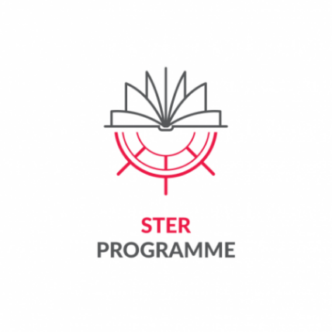
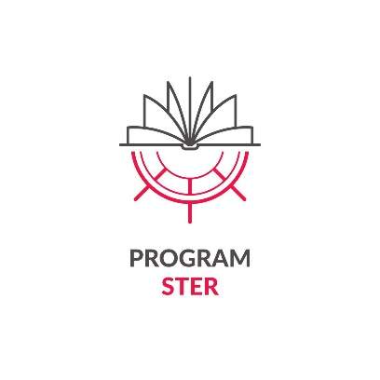
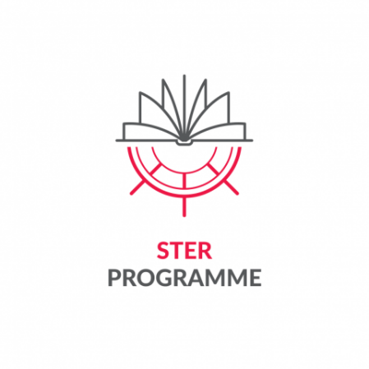


Appendix 8 to the Regulations for Participation in the Task
"Crossing Borders and Horizons" for the best doctoral candidates from Poland and abroad,
pursuing education at a doctoral school, as part of the project
titled: "IMPROVE - International Mission to Promote Research and Optimal Values in Education”
implemented by Lodz University of Technology as part of the programme STER - Internationalisation of Doctoral Schools - 2024 Call
financed by the National Agency for Academic Exchange

Substantive report on the implementation of mobility
by the Project Participant

Participant's name and surname
Receiving institution
Mobility implementation deadline

- Please describe how the objectives and planned activities during the mobility were achieved (max. 300 words)
- Please list specific outcomes/results of the planned mobility (e.g. published scientific articles, papers presented at conferences, prepared together with project partners, improved qualifications, etc.)
- Please indicate how the Participant plans to continue international collaboration with scientists at the host institution (max. 300 words)

Please attach to the report copies of works, materials and documents prepared by the Participant and created as part of or in connection with the implementation of the mobility.

place and date | signature
…………………………………………………… | …………………………………………………..

