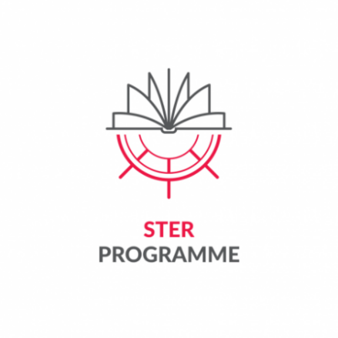**** ***Appendix 4 to the Regulations of Participation in the Task***

***"Crossing Borders and Horizons" for the best doctoral candidates from Poland and abroad,***

***pursuing training at the doctoral school, as part of the project***

***titled "IMPROVE - International Mission for Promoting Research and Optimal Values in Education"***

***implemented by Lodz University of Technology under the STER programme Internationalization of doctoral schools – 2024 Call***

***financed by the National Agency for Academic Exchange***

**Mobility funding application**

*Please send a scan of the completed application along with attachments to the email address of the Task Office or deliver the original documents to the Task Office.*

1. **APPLICANT’S DETAILS:**

|  |  |  |
| --- | --- | --- |
| **Name** |  | |
| **Surname** |  | |
| **Sex** | o Female  o Male | |
| **Date of birth** *(dd/mm/yyyy)* |  | |
| **Citizenship** |  | |
| **Doctoral candidate** | **Year of training** |  |
| **Name of the discipline** |  |
| **Supervisor**  *(at home university)* |  |
| **Co-supervisor/** **Assistant Supervisor** |  |
| **Email address**  Address in the domain *@dokt.p.lodz.pl* |  | |
| **Contact telephone number** |  | |

1. **REQUESTED MOBILITY**

|  |  |  |  |
| --- | --- | --- | --- |
| **Receiving institution**  *(name, address)* |  | | |
| **Place of departure/residence**  (*country, city where the applicant is currently staying*) |  | | |
| **Country of residence** *during mobility* |  | | |
| **Activity start and end date** *(dd/mm/yyyy,)* | First day of substantive activities: | | |
| Last day of substantive activities: | | |
| **Total number of mobility days** *(including 2 travel days)* |  | | |
| **Foreign language in which the mobility will be carried out** |  | **Proficiency in the language in which the mobility will be carried out at a level of at least B2.** | o YES  o NO |
| **Does the substantive scope of the planned activities relate to the Sustainable Development Goals?** (e.g. within the framework of ongoing research, prepared projects and scientific articles related to sustainable development) | Justification (max. 100 words): | | |

1. **JUSTIFICATION OF THE APPLICATION FOR MOBILITY FINANCING**

|  |
| --- |
| 1. **The thematic scope and method of implementation of the planned mobility. Description of the objectives and schedule of planned activities during the mobility. (min. 250 – max 600 words)** |
|  |
| **2. Description of the planned outcomes of mobility (e.g. publication of scientific articles, preparation of international project applications, conducting research using research infrastructure, etc.) (max. 250 words)** |
|  |
| **3. A short justification for the choice of a foreign centre (max. 100 words)** |
|  |
| **4. Current foreign cooperation of the applicant**  **Please provide documented results of the cooperation undertaken:**   * + - 1. **A publication or abstract from a conference presenting scientific research carried out in foreign cooperation - an abstract or the first page of the publication must be provided along with the name of the doctoral candidate and co-author from abroad**       2. **Other scientific work or event (e.g. joint organisation of conferences, exhibitions, other documentable achievements) carried out as part of international cooperation (please provide supporting documentation)**       3. **Other completed foreign mobilities, please provide documentation**       4. **Is the applicant participating in a joint degree program (double degree/joint degree) – yes/no** |
|  |
| **5. Please describe how the mobility requested by the applicant will help to enhance the value of the PhD? What teaching/learning-related activities are planned for the mobility period? How will mobility affect the research being carried out and planned? (min. 250 – max. 500 words)** |
|  |
| **6. The applicant's scientific/artistic achievements and output to date**   * 1. **scientific publications – list with IF and MEiN points, please indicate a maximum of 3 best publications published during training at ID TUL**   2. **active participation in international conferences - confirmation in the form of a certificate or a schedule with a list of the doctoral candidate's presentations, a maximum of 2 conferences must be provided**   3. **participation in research, implementation and educational projects, including international ones, in which the applicant took part during his/her training at IDS TUL**   4. **other, please indicate a maximum of 3 (including participation in courses improving the skills of doctoral candidates or active participation in promotional activities of IDS TUL)** |
|  |

**Required attachments:**

o A document confirming the readiness of the host institution to accept the applicant, including information on the mobility date, the schedule of planned substantive activities and consent to their implementation at the host entity, details of the Mobility Supervisor at the host institution.

o I declare that I have read and accept the Project Regulations and their attachments.

o I declare that the above data are factually correct.

|  |  |
| --- | --- |
| place and date | legible signature of the Applicant |
| …………………………………………………… | ………………………………………………….. |
|  |  |
|  |  |
| place and date | legible signature  Supervisor |
| …………………………………………………… | ………………………………………………….. |
| place and date | | legible signature  Co-supervisor/Assistant supervisor |
| …………………………………………………… | | ………………………………………………….. |

Completed by the Task Office:

|  |  |
| --- | --- |
| **Date and time of submitting the application to the Task Office** |  |