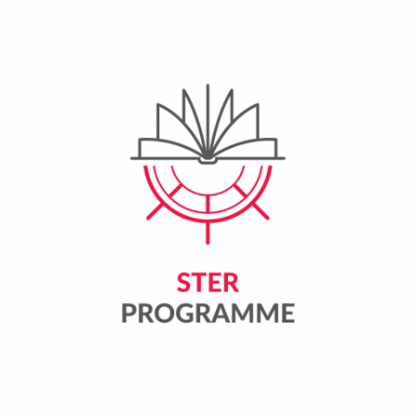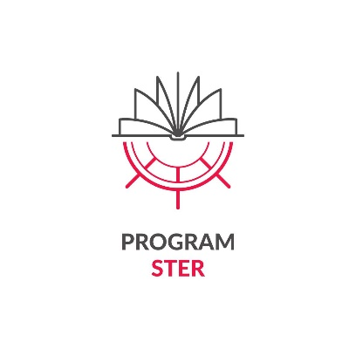****

***STER 2025 – Agreement Appendix 3 -***  
*Declaration of the Project Participant*

**DECLARATION OF THE PROJECT PARTICIPANT**

|  |  |
| --- | --- |
| **Identification of the programme and project to which the declaration relates** | |
| Institution announcing recruitment to the Programme | National Agency for Academic Exchange (hereinafter NAWA) |
| Name of the NAWA Programme and year of announcement | STER – Internationalisation of Doctoral Schools –  2024 Call |
| Name of the NAWA Beneficiary | Lodz University of Technology |
| Title of the NAWA Beneficiary's project | IMPROVE - International Mission to Promote Research and Optimal Values in Education |
| NAWA Beneficiary Project Number | BPI/STE/2024/1/00003 |

I, the undersigned

|  |  |
| --- | --- |
| Name |  |
| Surname |  |
| PESEL/passport number |  |
| Function in the NAWA Beneficiary's project | Participant* |

*delete where not applicable

I declare that:

1. I accept the principles of implementation of the NAWA Programme specified in the Announcement of the call for applications for participation in the Programme No. 10/2024 of 20/05/2024 and the appendices to the aforementioned Announcement: <https://nawa.gov.pl/instytucje/ster-umiedzynarodowienie-szkol-doktorskich/ogloszenie>;
2. I meet the criteria that allow me to participate in the NAWA Programme, i.e.:

- I have a current doctoral candidate status at IDS TUL

- my proficiency in a foreign language is at least B2

- I am not a citizen of the Russian Federation.

Having been warned of criminal liability under Article 233 of the Penal Code for making a false statement or concealing the truth, which provides for a penalty of imprisonment for up to 3 years, I declare that the data contained in this Statement is complete and true.

I acknowledge that this information may be subject to verification for truthfulness.

…………………………………………………………………………………

date and signature of the Project Participant

**Information clause of the National Agency for Academic Exchange regarding the processing of personal data of a project participant**

|  |  |
| --- | --- |
| Administrator | National Agency for Academic Exchange (Agency)  40 Polna, 00-635 Warszawa |
| Purpose and legal basis of data processing | The Agency processes your personal data on the basis of Article 6(1) letter c) of the GDPR.[1], in order to:   * performance of the public task in the field of internationalisation of higher education and science entrusted to the Agency, i.e. the task specified in Article 2 of the Act of 7 July 2017 on the National Agency for Academic Exchange; * the Agency’s fulfilment of legal obligations related to the implementation of the project, including obligations related to conducting controls, evaluations, statistical analyses and for archiving purposes. |
| Data processing period | Your personal data will be processed by the Agency until the purpose of processing ceases to exist or for the period resulting from the archival category of documents in which the data is included, specified in the implementing provisions to the Act of 14 July 1983 on national archival resources and archives. |
| Sharing/entrusting data | While maintaining all security guarantees, the Agency may make your data available to entities authorized to receive them under the law, or transfer them to entities processing them on behalf of the Agency under an appropriate data processing agreement. |
| Transfer of data to third countries | Your data will not be transferred to a third country or an international organisation. If it is necessary to transfer data to a third country, the Agency will provide appropriate safeguards for the transfer of such data and effective legal remedies, in particular standard contractual clauses adopted by the European Commission, and will inform you about this fact. |
| Making decisions based solely on  automated processing of personal data, including profiling | Does not occur. |
| Data requirement/data source | Providing your data is voluntary, but necessary to participate in the programme. Refusal to provide data means that the application will not be considered or that participation in the program will be impossible. |
| Data subject rights | You may submit to the Agency an application for access to your personal data, rectification of data and restriction of the processing of personal data - under the principles set out in the GDPR.  You may lodge a complaint with the President of the Personal Data Protection Office if you believe that the processing of your data by the Agency violates the law. |
| Contact to the data protection officer at the Agency | odo@nawa.gov.pl |

**PARTICIPANT'S CONSENT TO DATA AND IMAGE PROCESSING**

**I voluntarily consent to** the recording of my image in the form of an analogue photograph, digital photograph or recording by the National Agency for Academic Exchange (Administrator) and the free use of my image (with the possibility of describing it with my name and surname, position, title, institution, country of origin, program I used) for the purposes indicated below (please check the appropriate box or boxes below):

☐ dissemination of studies and publication on the Administrator’s website,

☐ dissemination of studies and publication on the Administrator’s social media,

☐ publication in the Administrator’s offer, advertising or promotional materials,

☐ dissemination of studies and publication in the Administrator’s internal materials (e.g. on the notice board),  
☐ publication of studies in printed form.

…………………………………………………………………………………

date and signature of the Project Participant

**INFORMATION CLAUSE REGARDING IMAGE PROCESSING**

The administrator of your data in the form of an image within the meaning of the General Data Protection Regulation (GDPR) is the National Agency for Academic Exchange (40 Polna, 00-635 Warsaw). The data are processed for the purposes indicated above, based on voluntary consent (Article 6, paragraph 1, letter a of the GDPR, Article 81 of the Act of 4 February 1994 on copyright and related rights). This consent may be withdrawn at any time, but the withdrawal of consent will not affect the lawfulness of data processing during the period in which the consent was in force. Data may be transferred to entities cooperating with the Administrator (e.g. companies operating the Administrator's websites) on the basis of a data processing agreement. The data subject has the right to access personal data, rectify it, delete it, limit its processing or file a complaint with the supervisory authority – under the terms set out in the GDPR. Contact for personal data protection matters: odo@nawa.gov.pl. Dissemination of an image that is only a detail of a whole (group photos, photos/recordings from meetings, photos/recordings where the image of the person is not the main or basic element of the shot) does not require consent (legal basis: Article 81 sec. 2 item 1 of the GDPR). 2 Act of 4 February 1994 on copyright and related rights).

1. Regulation (EU) 2016/679 of the European Parliament and of the Council of 27 April 2016 on the protection of natural persons with regard to the processing of personal data and on the free movement of such data, and repealing Directive 95/46/EC