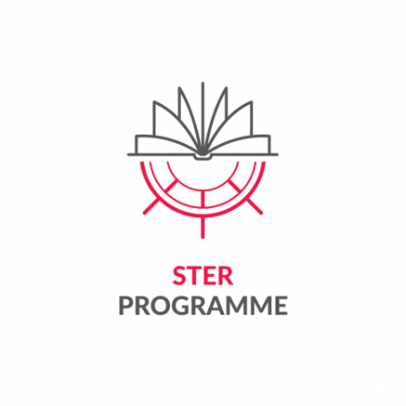

Appendix 8 to the Regulations for Participation in the task
"Cadet's wings - mobility support" implemented as part of the project entitled "Curriculum
for advanced doctoral education & training - CADET Academy of TUL"
by Lodz University of Technology as part of the STER programme entitled Internationalisation of
Doctoral Schools funded by the National Agency for Academic Exchange.

Project Participant Substantive Report on the Implementation of Mobility

Participant first name and surname
Host Institution
Mobility implementation date

- Describe how the objectives and planned activities during the mobility were achieved (max. 300 words)
- List specific outcomes/results of the planned mobility (e.g., academic articles published, papers delivered at conferences, jointly prepared activities with partners, improved qualifications, etc.).
- Indicate how you plan to continue your international cooperation with researchers at the host institution (max. 300 words)

Attach copies of works, materials, documents produced by the Participant within the framework of or in connection with the mobility to the report.

Place and date | Signature
…………………………………………………… | …………………………………………………..

